Assignment 1 with solution

Install Power BI Desktop and share the final screenshot of the report view page which appears when power desktop starts. -Solution

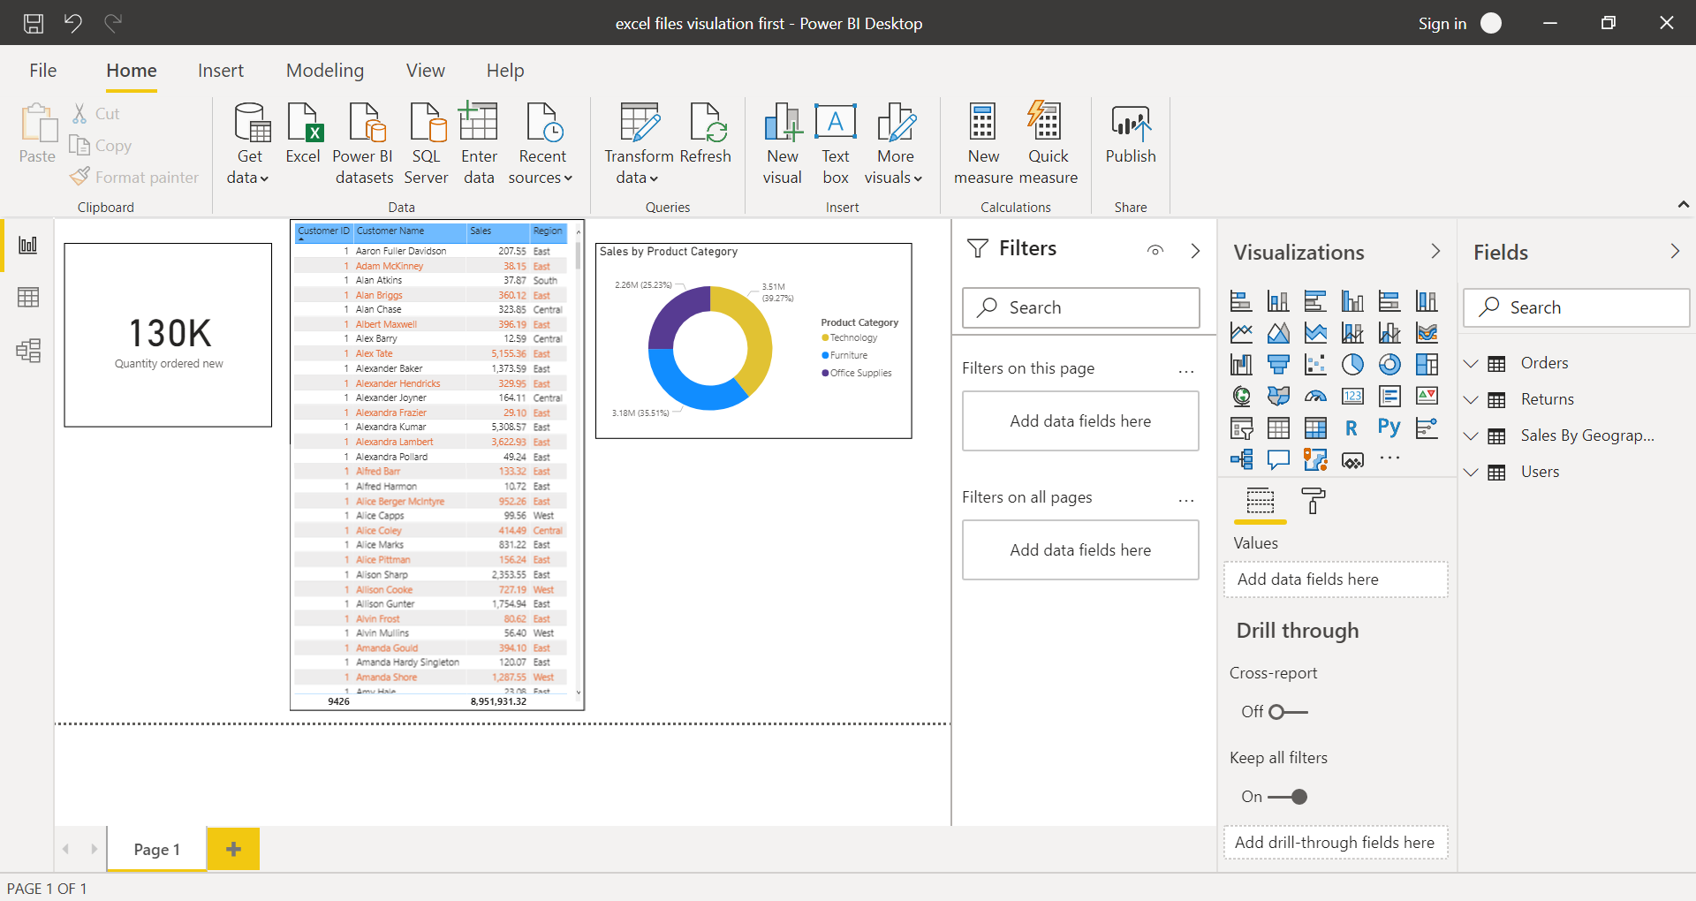

Prepare a document and with the following screenshot

− Report View

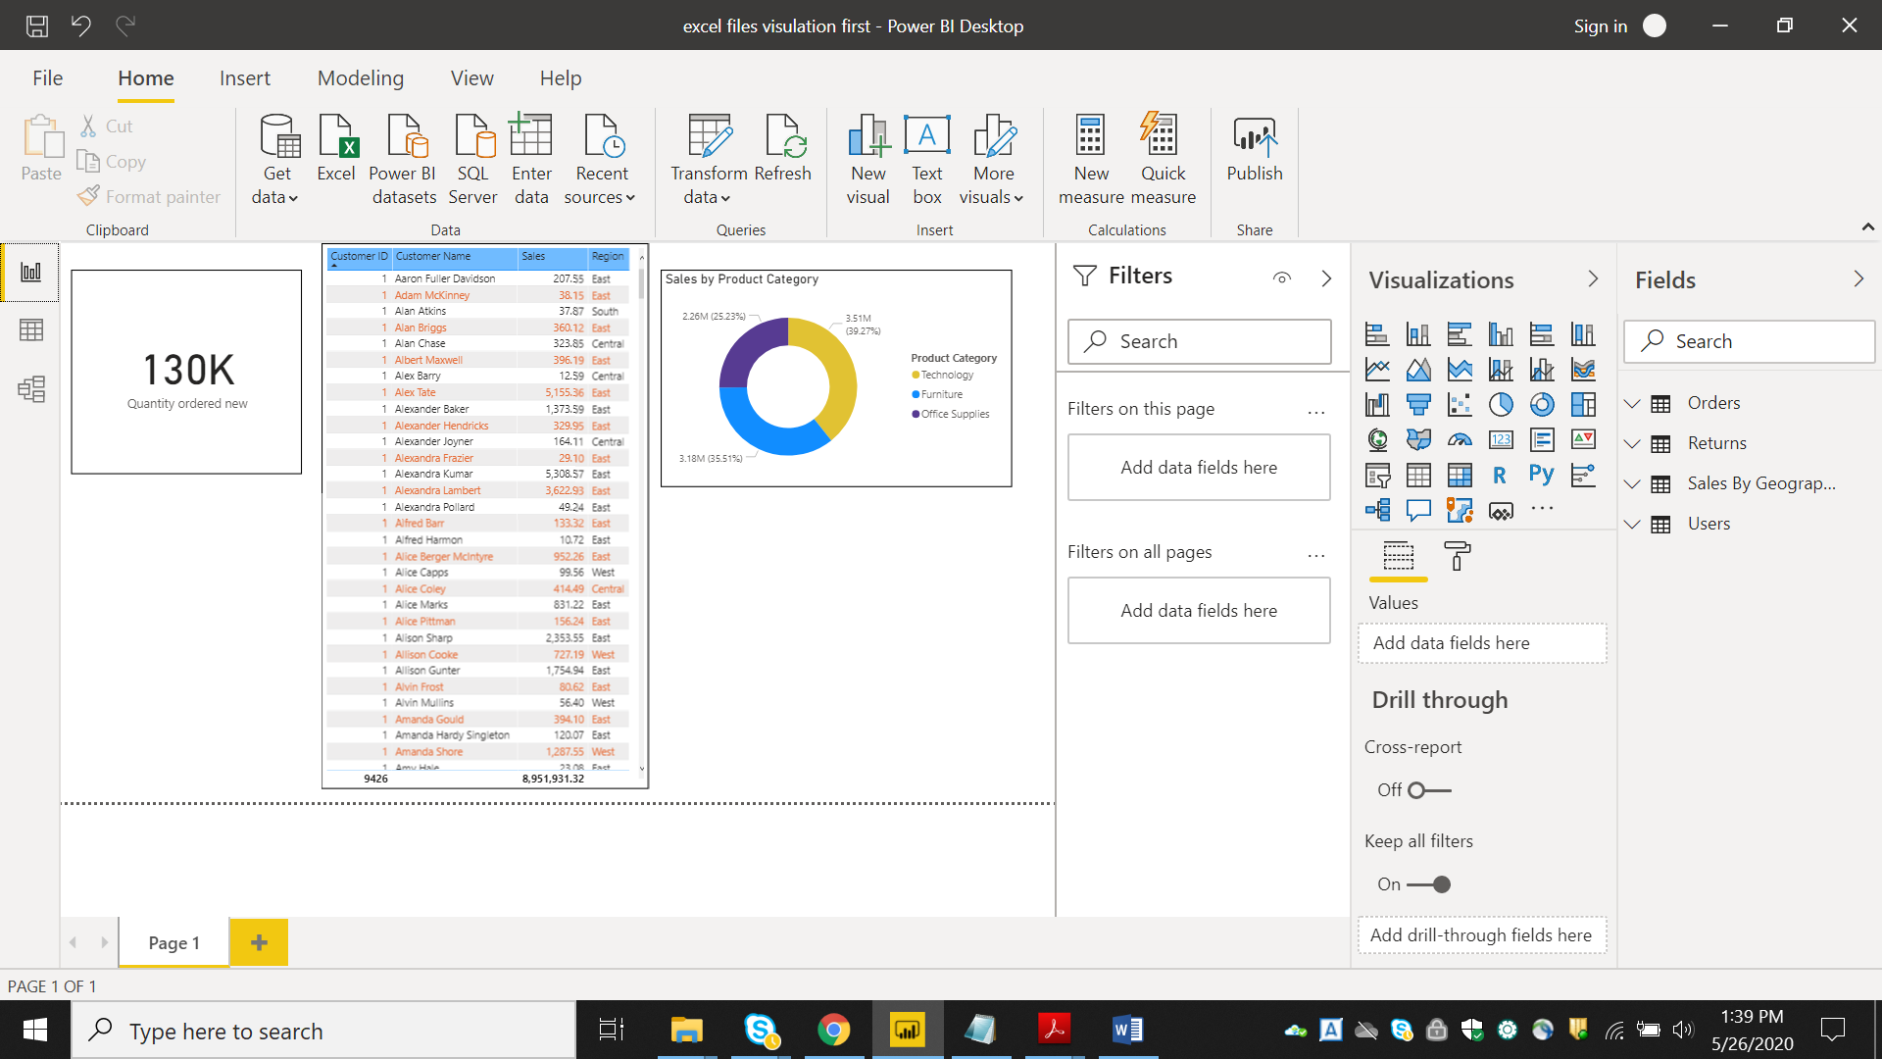

− Data View

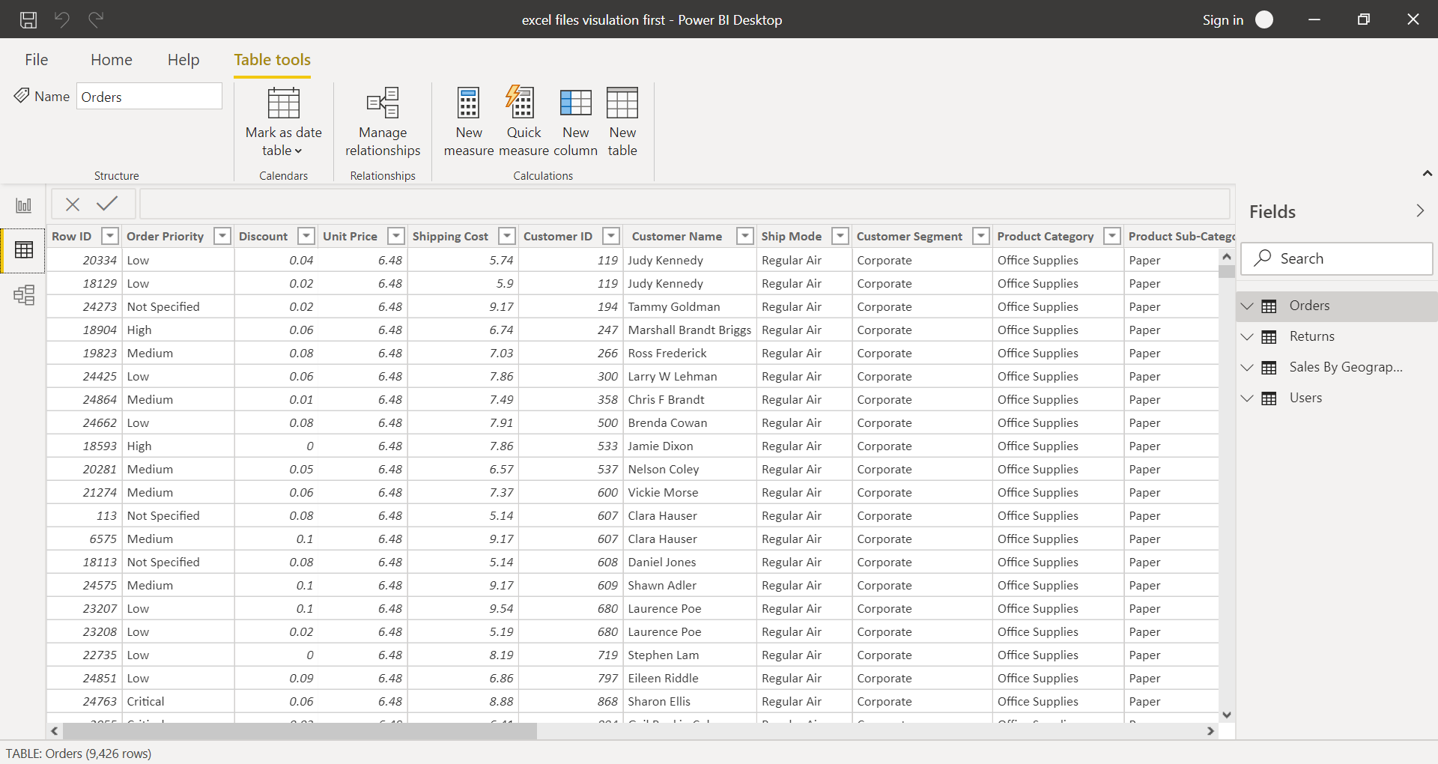

− Model View

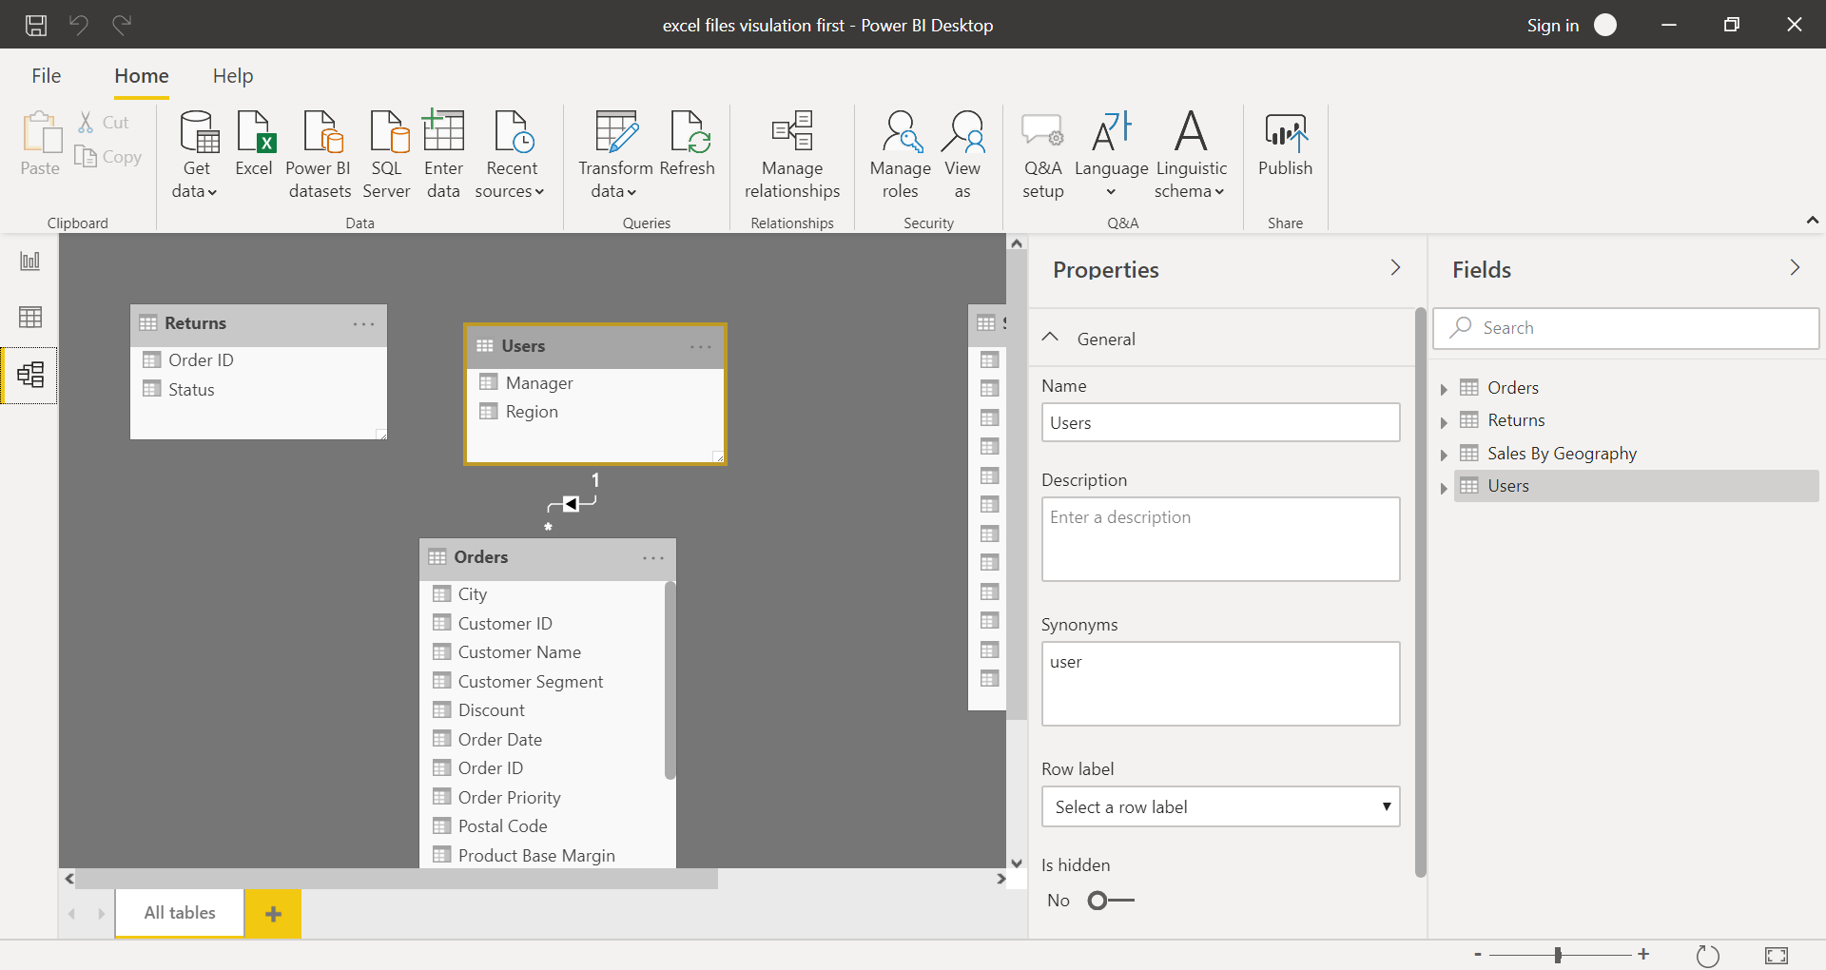

− Power Query Editor

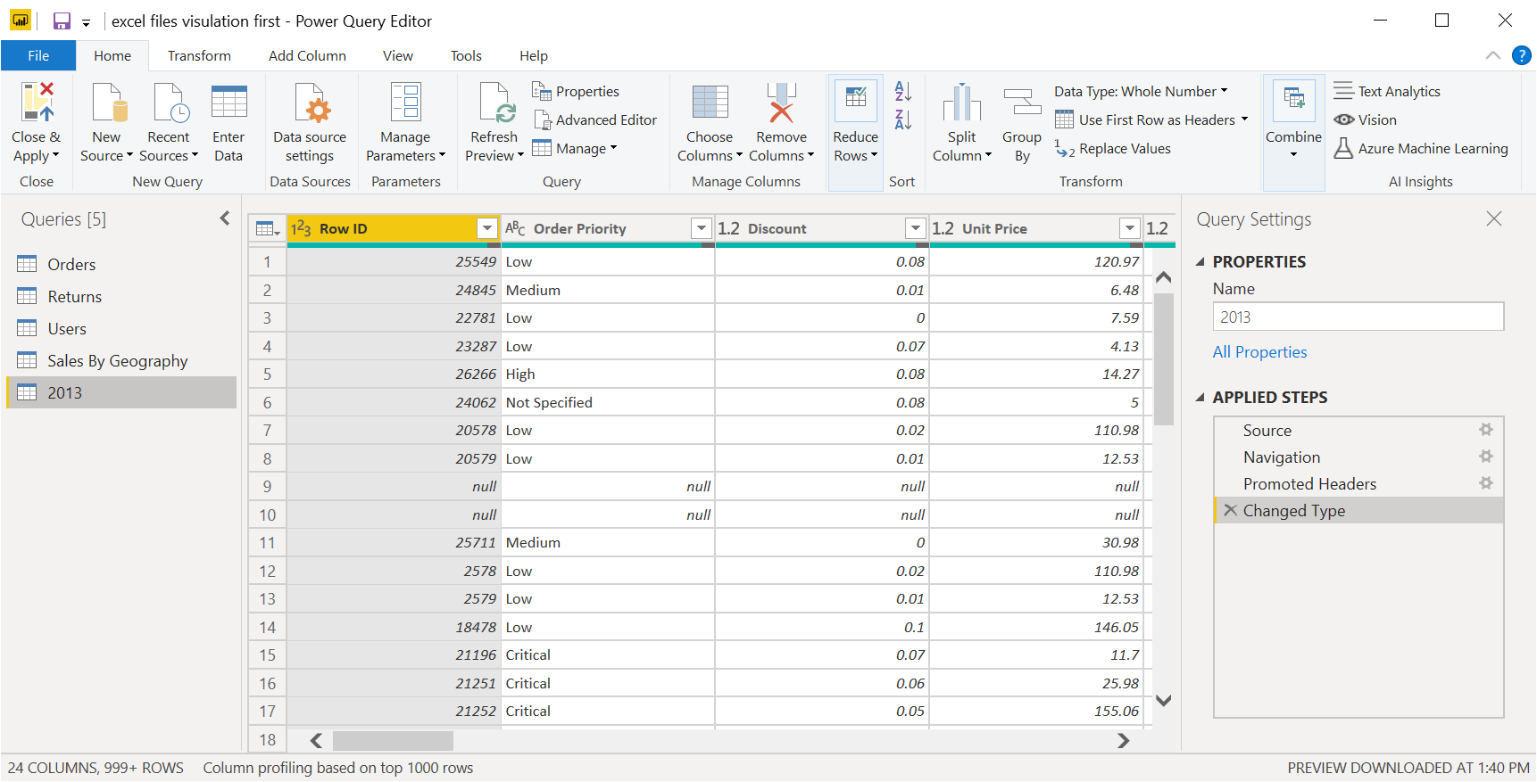

− Advance Editor

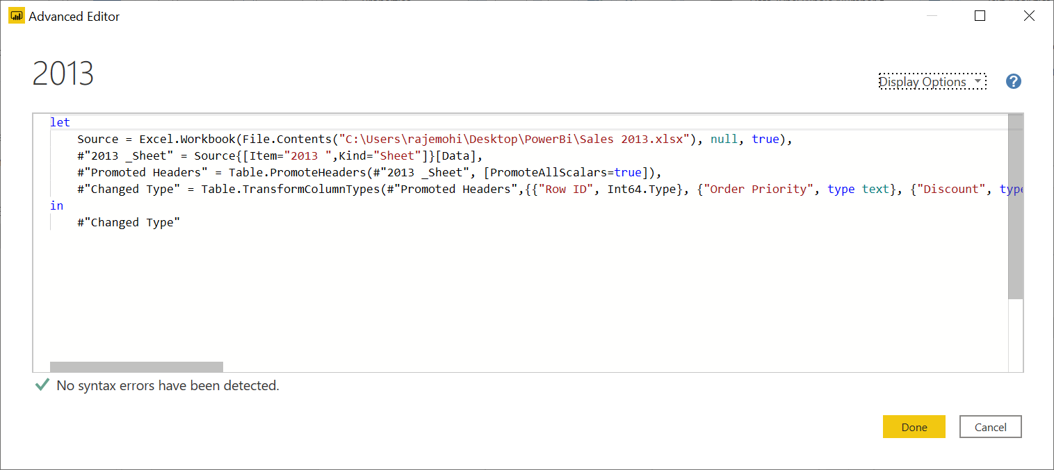

Prepare a document with details of the following along with their price

− Power BI Desktop

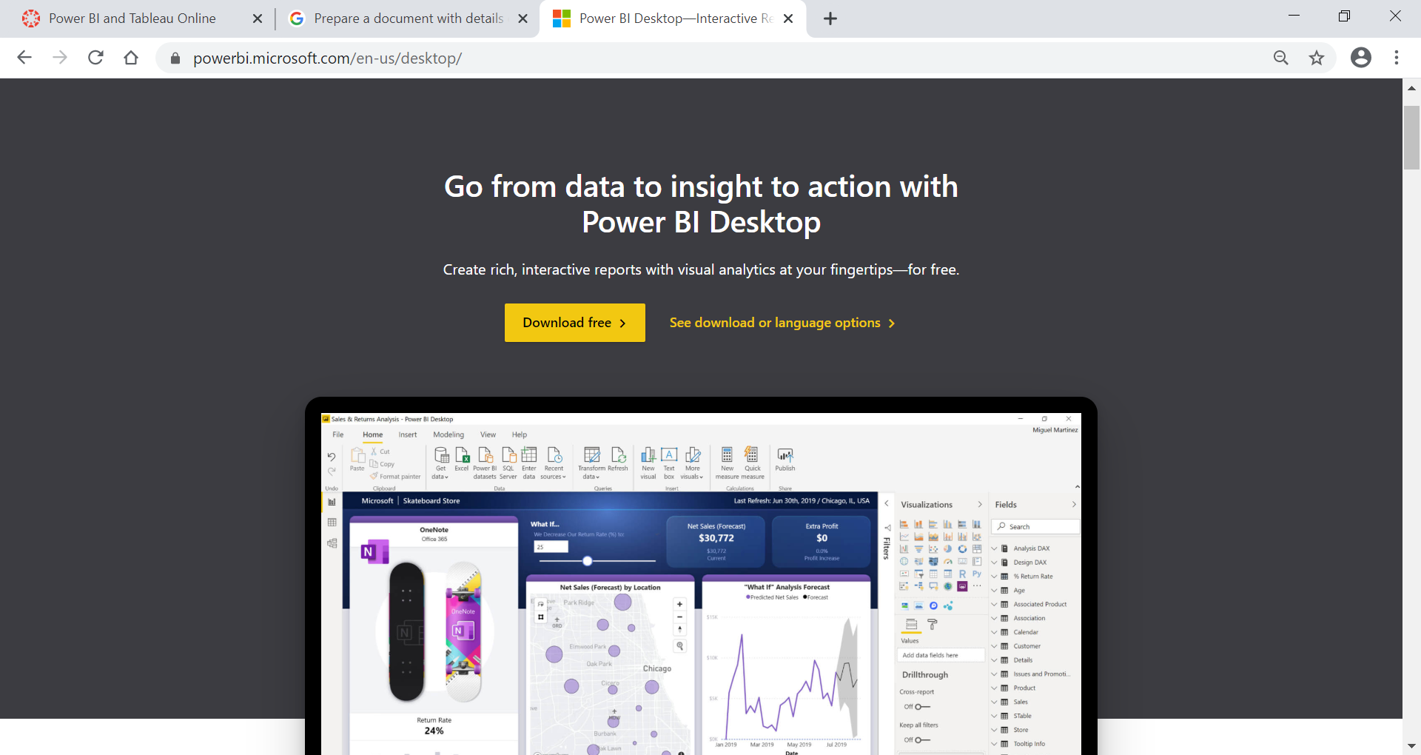

− Power BI Pro and − Power BI Premium

